Name: ____Yunis __________________________

Lesson: Unit 2 – Python Dictionaries

1. Create a simple dictionary that stores 2 variables, for example: first and last name.

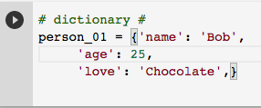

1. Print out those variables stored in your previous dictionary.

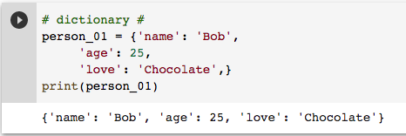

1. Add a message to those variables on printing: for example: “Hello, firstname lastname!”

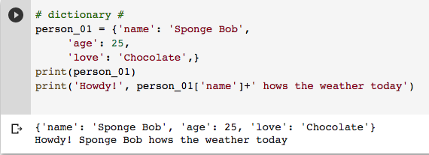

1. Create a dictionary that holds 2 key: value pairs:
   1. Look through your dictionary and print each pair,

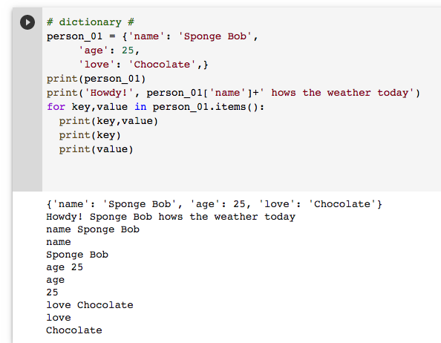

1. Create a nested dictionary containing three dictionaries – these dictionaries could be anything (favorite pets, travel locations, etc.)
   1. Loop through the dictionaries and print a message for each.

